Date: January 14, 2026
Location: Zoom Virtual Meeting
Time: 7:00pm
Meeting Called to Order: 7:04pm by Liz Young – PTA President of Presiding Officers
Meeting Adjourned At: 7:44pm

PRINCIPALS REPORT:

Mid-Year Testing and Updates

Currently, we are conducting mid-year assessments, The Measures of Academic Progress (MAP) Math and Reading. Most of our students have either completed or are about to take their math tests. They initially took this diagnostic assessment at the beginning of the year, and now we're evaluating their growth. The key questions are: Have they shown improvement or not? And if not, what steps will our school and teachers take to address this?
Principal Announcement
In addition, I wanted to address that, as of now, there has not been a principal announcement. I have been assured that an announcement will be made within the next couple of weeks regarding our new LAES Principal now that Michelle Makrigiorgos has retired.

Communication Updates
If you need anything, please remember that I am the school administrator, and I am here to assist you. I have no plans to be away from school, so feel free to reach out to me. My email is jgcondra@fcps.edu, or you can contact me via our website. I want to ensure that everyone knows I am your point of contact if you require assistance or need to speak with an administrator.
Appreciation
Lastly, I want to express my gratitude for your support. Our cookie carry in December was a huge success, and our staff genuinely looked forward to it. I appreciate all the behind-the-scenes efforts that made it happen, including the addition of a hot chocolate bar this year, which was a delightful new feature.
As we approach the upcoming stocking of the fridge, I sincerely appreciate your thoughtfulness for our staff and all the pop-up parties. It’s certainly noticed and valued!

TREASURER’S REPORT
Here’s a brief update: everything is currently on budget, and many of our programs are being utilized effectively.
- Reimbursements: A number of teachers have taken advantage of their $100 annual reimbursement per classroom, which has been fantastic. The items processed so far have been wonderful additions to the classrooms.
Looking ahead, we have a schedule filled with exciting events, including several fundraisers. We encourage everyone to spread the word as these events approach, as fundraising is always beneficial.
At present, we have approximately $33,000 in the bank, which aligns with our expectations. We will continue to process the remaining programs as the year progresses. Thank you!
PRESIDENT’S REPORT

Committee Updates and Announcements
- Before & After School Activities
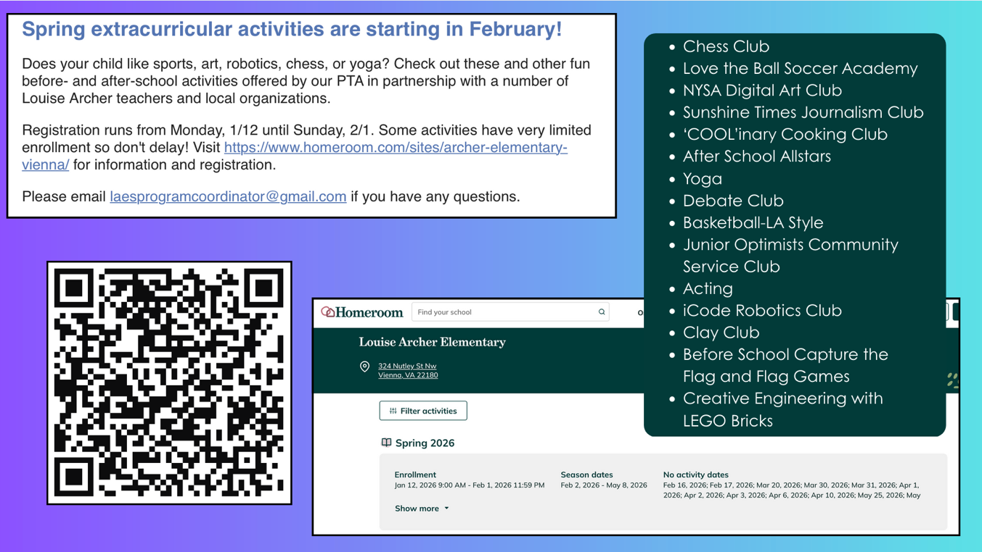
  - Spring extracurricular activities start in February. There will be engaging activities offered both before and after school, from 8:00 to 9:00 AM and from 4:00 to 5:00 PM. Please register via Homeroom at https://www.homeroom.com/sites/louise-archer-elementary-vienna/enrichment

- Spirit Wear - Free Shipping
  - Spiritwear is offering free shipping week is coming up from this Friday, January 16th-23rd. If you’d like to take advantage of this offer, you can purchase a variety of Louise Archer merchandise at https://louisearcherspiritwear.com/
- LAES PTA Parents' Night Out Concert
  - Our first fundraiser of 2026 is just around the corner! While we have skate night—a community gathering—our major fundraiser will be held in early February, Parents’ Night Out, which we introduced last year. This event is incredibly fun, allowing parents to leave their kids with a babysitter or a trusted family member and enjoy a night out.
    - Event Highlights:
      - Two cover bands will perform starting at 7:00 PM, featuring talented dads from Aries Archer, which adds to the excitement.
      - Tickets are currently on sale, so if your child is interested, be sure to sign up!

Stock the Fridge Initiative
This important event is set for January 29th and 30th. Our teachers genuinely appreciate your contributions! You can sign up via the QR code and drop off items at the front office on the 28th, or you can deliver them to our Vice President, Sarah's house, by Wednesday the 28th. If you prefer this option, you can email her directly for her address at vicepresident@louisearcherpta.org to coordinate.
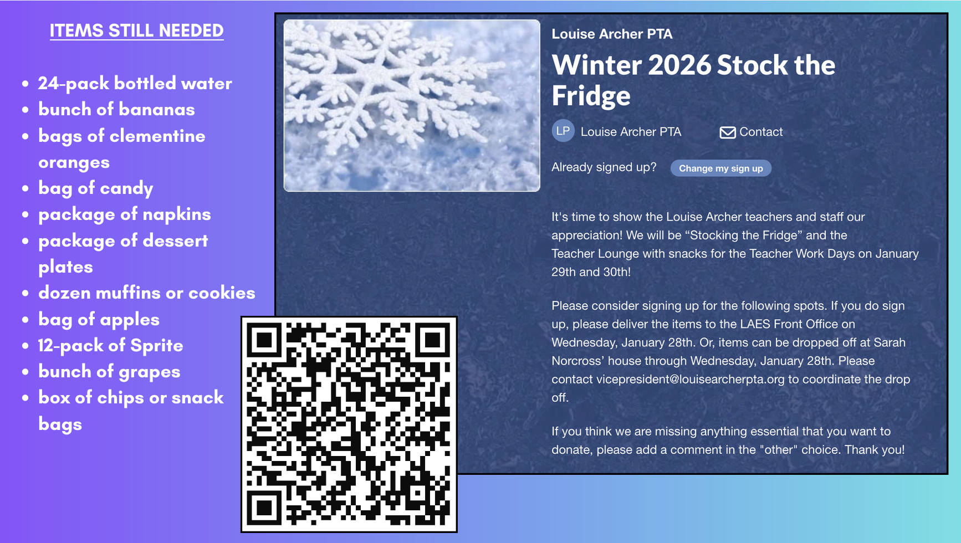
Volunteer Opportunities
The STEAM Fair will be taking place in April. We welcome any parents or older student volunteers who are interested in leading STEAM activities. It’s a fantastic opportunity for middle and high school students seeking service hours. For more information, they can reach out to the PTA, specifically to Erin Simpler. If you have trouble finding her email, you can contact me at president@louisearcherpta.org, and I’ll direct you. If there are other upcoming events needing volunteers, especially where high school students can assist, Erin can connect you with the robotics chair at Madison, as they are looking for volunteer hours.
Room Parent Communications
Our PTA Vice President, Sarah Norcross, who couldn’t join us tonight coordinates with all the room parents. If you are a committee chair and have any updates regarding events, meetings, or volunteer reminders for the Room Parent distribution list, please email Sarah at vicepresident@louisearcherpta.org. She plans to send out the next round of notices to Room Parents on the 20th, next Tuesday, so please send her your information by then.
Faculty Volleyball Game Chairs Needed
Lastly, you may have noticed in the Sunbeam that we are looking for a faculty volleyball team. For those who have been with us for a while, you know this game is an exciting PTA event where staff from Wolftrap Elementary and Louise Archer Elementary compete for bragging rights. It’s been a close match in recent years, with Wolftrap narrowly winning, and we want to ensure the game happens again, regardless of the outcome. However, we need someone to chair this committee. For more details about the faculty volleyball game committee and its time commitment, please check the PTA website at https://louisearcherpta.org/pta-position-descriptions-and-openings/#OPEN_Faculty_Volleyball_Game_CommitteeCOMMITTEE NOTES ON UPCOMING EVENTS
Pizza Bingo - Andrea LoBalbo

Pizza Bingo is set for March 13th, maintaining the same schedule as last year, from 5:30 PM to 7:15 PM. We will enjoy 45 minutes of pizza from 5:30 PM to 6:15 PM, followed by an hour of Bingo. Mrs. Skousen has confirmed her participation, and there's a possibility that Mrs. Kitchen may return as a guest caller.

Funding - We need to decide if the event will be classified as a fundraiser or community event as there seems to be some confusion. A separate conversation with Dan, our Treasurer, will be had.

Advertising - Derek, our webmaster, is the contact for Sunbeam and Sunburst information. Event notifications or volunteer requests can be emailed to Webmaster@louisearcherpta.org

Pre-Order Details - Having pre-orders for pizza has significantly improved the flow and helped order the correct amount of food. Clarification needed on who will manage it on the web store. (Also, Derek)

Yearbook Photo Submissions - For yearbook photo submissions, you can send photos to yearbook@louisearcherpta.org. Typically, we recommend notifying the yearbook committee ahead of time, as they can create a separate folder for specific events, making it easier for them to organize submissions.
Sunshine Times Newspaper - Linnea Osborne
The Sunshine Times serves as our annual student newspaper, where students are encouraged to submit artwork and written pieces on various topics. Participation is open to everyone, including kindergarteners, which is fantastic!
Important Updates - Originally, our submission deadline was this past Sunday. However, due to feedback regarding issues with the submission link, we've decided to extend the deadline. The new deadline will is Wednesday, February 4th. We will communicate this update through classroom channels, parents, Sunbeam, etc.
A Celebrated Tradition - Last year, we proudly received submissions from over 50, nearly 60 students. We accept all entries as long as they are school-appropriate, and everything is published—there's no judgment involved. It's a wonderful opportunity for students to showcase their creativity.
Budget Considerations - One important note is that producing the Sunshine Times incurs costs for the PTA. While it is not a fundraiser or cost-neutral, we want to encourage participation. Last year, we exceeded our budget due to high participation levels, so we are aware of the newspaper's expenses. To address this, we might explore sponsorship opportunities and advertisements within the newspaper, and we’re eager to find the best way forward.
Journalism Club - Regarding the before and after-school programs, there is indeed a Sunshine Times Committee meeting. This is part of the journalism club led by McKay Coppins, a renowned journalist, best-selling author, and a Louise Archer parent of three. They meet once a month, and professionals from McKay’s network assist students in refining their journalism skills. Members of the journalism club will also contribute to the newspaper and help with editing the layout, providing them with a hands-on experience.
Participation in the journalism club is limited, so if anyone is interested, please keep that in mind for next year. And remember, students do not need to be part of the journalism club to contribute to the newspaper. It's an exciting opportunity for all!
Mini Grants - Cathy Chen
Successful First Round of Mini Grants - We had an incredibly successful first round of mini grants this fall. Out of 11 applications submitted by teachers, we granted all but one. The PTA awarded approximately $2,800 for the ten grants.
Highlights of the Grants
- PE Supplies: Foam paddles were requested by PE teachers for the pickleball unit.
- Music Equipment: We purchased two gongs for music class, which you might spot at the next band concert.
- Classroom Essentials:
  - Flexible seating options
  - Books and math resources
  - Replenished beanbag chairs and fidget toys for common corners in classrooms.
I want to extend a huge thank you to Dan for coordinating with the teachers and managing the orders, as that involves a lot of work!
Upcoming Grants - We have about $2,000 remaining for the second round of mini grants, and applications will be distributed soon.
Original Works - Cathy Chen
This annual art fundraiser organized by the PTA has a submission deadline for students' artwork around mid-February this year. I know students are diligently creating their masterpieces in art class right now. Once the artwork is submitted in mid-February, students will bring home ordering information in early March. The PTA receives a portion of any orders placed by parents, and the proceeds will be used for next year’s initiatives.
Reflections Program - Reshma Patel
A Heartfelt Appreciation for Our Committee
Every child who participated left with new ideas for the next year, which made me very happy. We had a wonderful turnout, with 33 entries and about 30 children participating. Some students submitted multiple entries, which was allowed across different art categories.
I'm thrilled to share that 11 entries will move on to regionals, although I haven't yet received any updates on their assessment. Our primary goal was to run the program and encourage students across all categories—from visual arts to music, encompassing everything.
The theme this year was "I Belong." For those who missed our exciting advertising campaign, I was brought to tears by many of the works submitted. It was incredible to see what our students, from kindergarten to sixth grade, created. I truly appreciate everyone who contributed to making this experience possible.
If anyone is interested in joining the team next year, I would love to have you on board. I’ll be around for two more years, but I want to avoid any gaps, like previous years. We have some great ideas for next year, and my goal is to surpass 50 entries.
I’m excited to encourage our talented students to participate, as their creativity is amazing. When I saw this year’s theme, I knew we would receive phenomenal submissions. Thank you for taking this on this year; many people are sincerely grateful. I’m already looking forward to next year—perhaps I’ll be on the committee alongside you! Let's finish strong and celebrate our school’s style ceremony. Our team was incredible!
Readathon - Elizabeth Chew
The LAES book fair is scheduled for March 2nd through 6th. From what I understand, it’s beneficial to coordinate our plans with this timeline. I noticed on Readathon’s website that they recommend hosting it for at least two weeks. I'm unsure how long we’ve done it in the past, and whether it makes more sense to start or conclude with the book fair. Does anyone have any insights on this? [Reply] If I recall correctly, two years ago, we ran it for about 11 or 12 days because they suggested that duration. However, based on the results, it seemed to lose momentum. Last year, we shortened it to just a week. Ultimately, there’s no definite right or wrong answer; it's really about how we want to approach it.
International Night - Arvind Jairam
International Night is scheduled for Friday, May 1st. This year, I will be partnering with David Jacobstein and Azadeh Rezvani. We intend to host it in the cafeteria, as we have done in past years. Over the next few months, we will provide notifications, schedules, and all the necessary details.

UPCOMING EVENTS CALENDAR

January
1/19/2026 Holiday | MLK Jr. Day
1/24/2026 Skate Night (6:10 - 8:00pm)
1/26-27/2026 Dining for Dollars: Vienna Inn (8am - 10pm)
1/28/2026 Stock the Fridge
1/28/2026 End of 2nd Quarter Early Release
1/29/2026 Student Holiday | Staff Dev. Day
1/30/2026 Student Holiday | Teacher Workday

February
2/7/2026 Parents' Night Out Concer
2/9/2026 Pop-Up Party (French Theme)
2/16/2026 Holiday | Presidents’ Day
2/17/2026 Student Holiday | Planning Day
2/18/2026 Limited Early Release Wednesdays
Date TBD Dining for Dollars

March
3/2–6/2026 Read-A-Thon (pending)
3/4/2026 Superintendent’s Family Vision Group
3/13/2026 Pizza Bingo
3/18/2026 Limited Early Release Wednesdays
3/20/2026 Holiday | Eid al-Fitr
3/25/2026 Walking Wednesday Returns
3/27/2026 End of Third Quarter – Early Release
3/30–31/2026 Spring Break
Date TBD Dining for Dollars

Final Reminders & Closing
- Board Availability:
  - Although only three general meetings are scheduled this year, the PTA Executive Board remains active year-round and available to all members.
- Contact:
  - For questions or to volunteer, email president@louisearcherpta.org
Meeting Adjourned

